Busurmankul Kyzy Meerimgul
 | 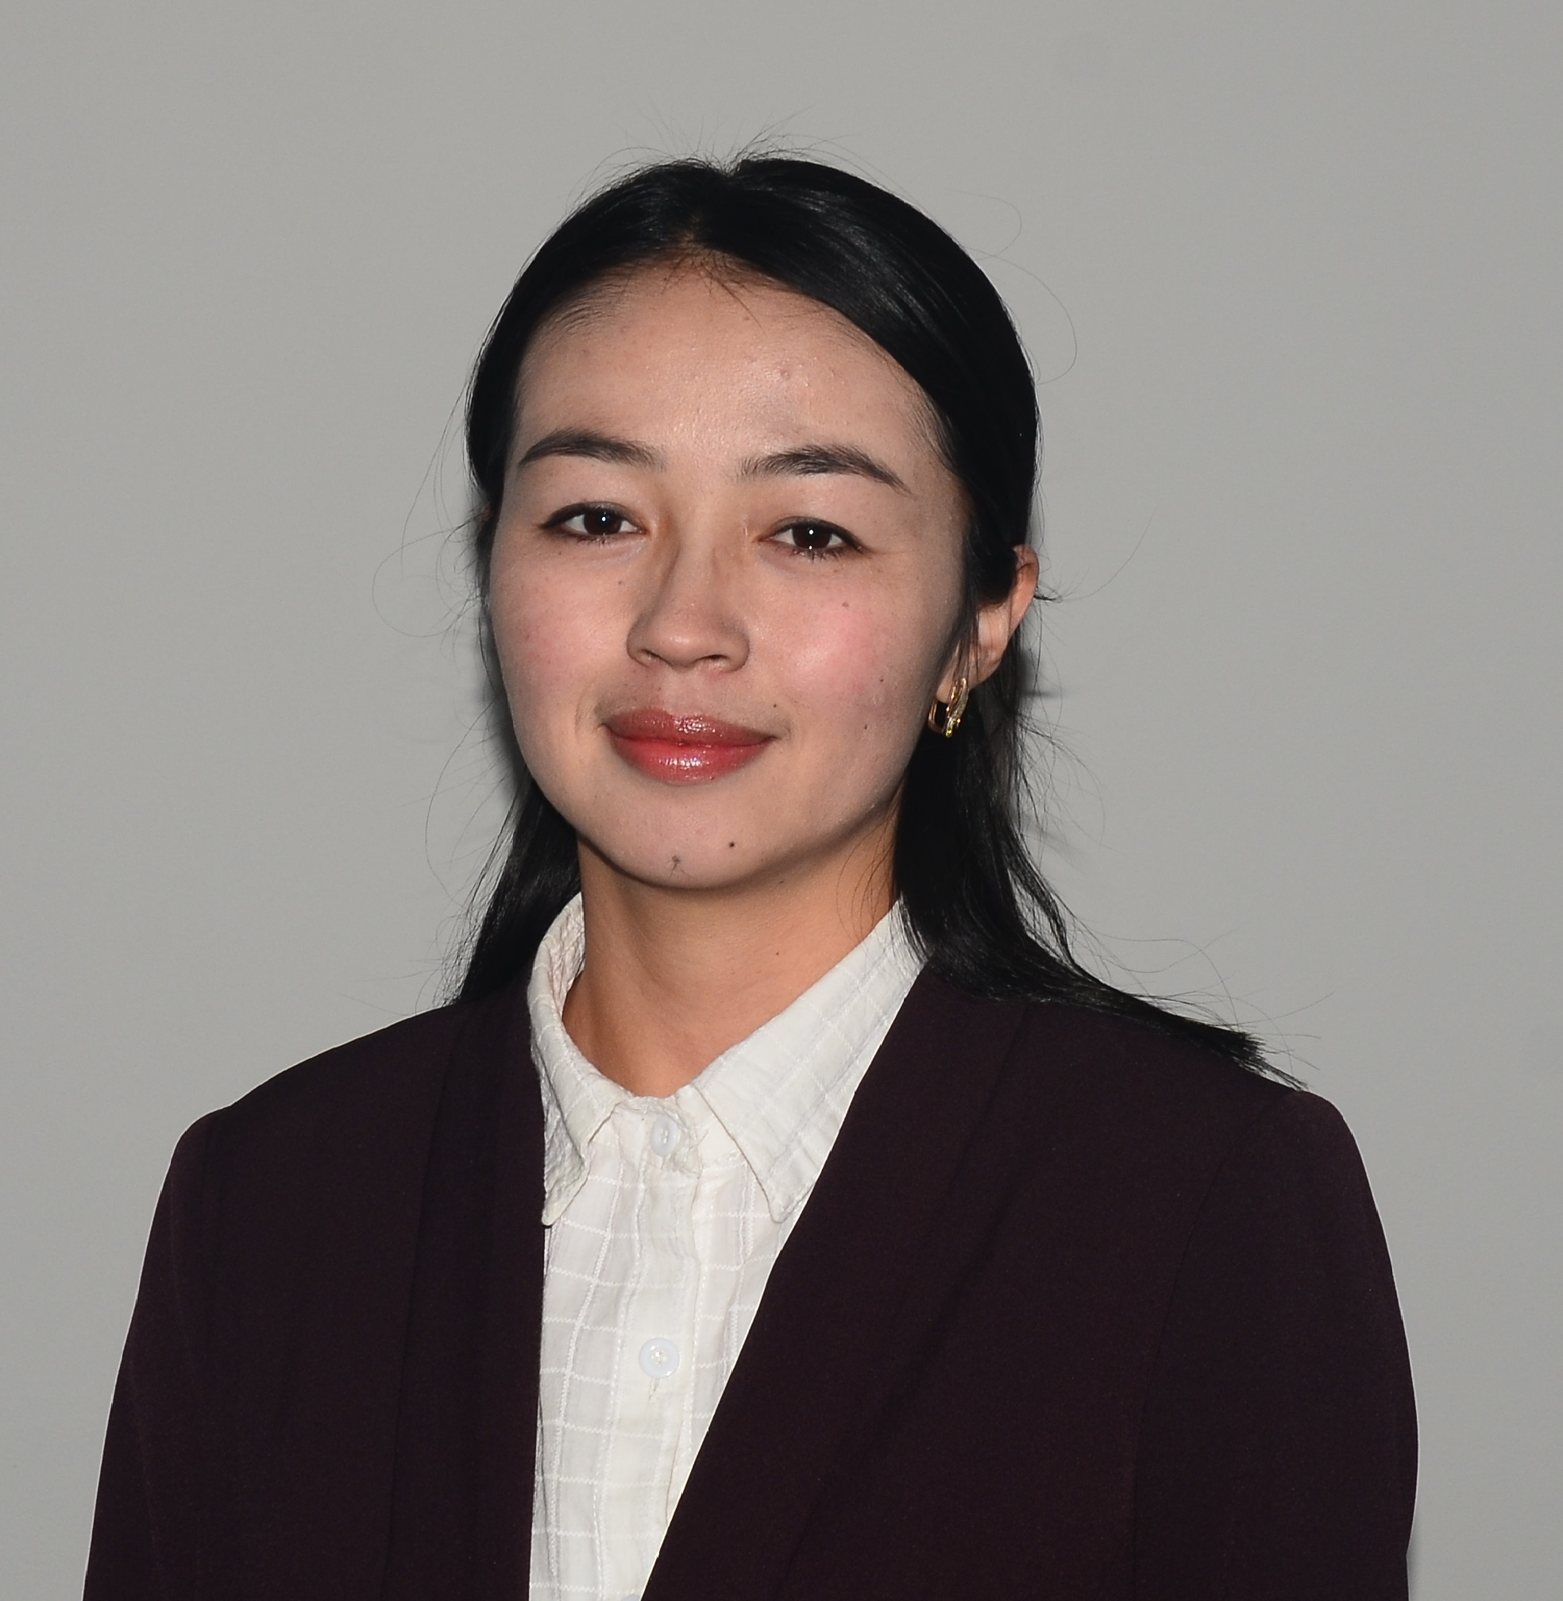 |  |  |  |  | 1.Busurmankul kyzy Meerimgul, was born on Novomber 16.11.1993. 2.Nationality: kyrgyz.  3.In 2011 Graduated School M.Kurenkeev  4.Graduated Faculty of Foreign Languages, Osh State University specialty “English teacher.”  5.Pedagogical experience 3 years at OshSU  6.Professional sphere of occupation- professional English and Latin
 | Peronal information
 | SURNAME |  |  |  | Busurmankul kyzy
 | NAME |  |  |  | Meerimgul
 | FATHER’S NAME
 | DATE OF BIRTH |  |  |  | 16.11.1993.
 | CONTACTS: |  |  | Office number |  |  |  |  | 0550305952
 |  |  |  | Home phone number
 |  |  |  | Mobile phone |  |  |  |  | 0550305952
 |  |  |  | E-mail |  |  |  |  | meerimkozonova1@gmail.com
 |  |  |  | Office number
 | EDUCATION:
 | Graduation | University |  |  |  |  | Faculty |  |  |  | Specialty
 | 2012-2016 | OshSU |  |  |  |  | Faculty of Foreign Languages |  |  |  | English language teacher
 | qualifications/ EXPIRIENCE IN ACCREDITATION и QUALITY ASSURANCE (TRANINGS, SEMINARS, CONFERENCES ETC.)
 | Beginning and graduation date | Name
 | 27-28.08.18 | “Система обеспечения качества образования”
 | 3-4.10.18 | “Academic Research and Writing”
 | 29-30.11.2018 | “B-Learning Modules in Occupational and Environmental Health”
 | 12-13.09.2018 | “ Teachers Helping Teachers”
 | experience
  - Febrary 2016- June 2016 English teacher at school A.S Pushkin
  - September, 2016 to present –teaching English at International Medical Faculty, Osh State University.
 | LANGUAGES: FROM 1 TO 5 (1 – PERFECT, 5 – BASIC KNOWLEDGE)
 | Language |  | Reading |  |  |  |  | Speaking |  | Writing
 | Kyrgyz |  | 1 |  |  |  |  | 1 |  | 1
 | Russian |  | 1 |  |  |  |  | 1 |  | 1
 | English |  | 1 |  |  |  |  | 1 |  | 1
 | additional information
Personal information and skills
Computer skills: MSoffice, Exell.
- Passport data: Personal number:116111993300517, AN1870145,
IM 50-42
- Marital status: married

